**UML - NIKHIL ARORA – A20339503**

**ASSIGNMENT NO: 1**

Deliverables:

* List of actors

|  |  |
| --- | --- |
| **S. No.** | **Actor Name** |
| 1. | Customer |
| 2. | Chef |
| 3. | Salesman |
| 4. | System |
| 5. | Delivery Person |
| 6. | Store Manager |

* Below are the number of important use cases

|  |  |
| --- | --- |
| **Use Case Number** | **Use Case** |
| 1. | Create Order |
| 2. | Pizza Options |
| 3. | Coupons |
| 4. | Check if inside restricted area |
| 5. | Customer verified |
| 6. | Guest/Member |
| 7. | Order Type |
| 8. | Payment Option |
| 9. | Delivery Option |
| 10. | Order Received |
| 11. | Delivery Address |
| 12. | Driver Location |
| 13. | Pending Orders |
| 14. | Order Status |
| 15. | Update/Cancel order |
| 16. | Order Received by Customer |

* Actors associated with the Use-Cases:

|  |  |
| --- | --- |
| **ACTOR** | **ASSOCIATED USE CASE** |
| CUSTOMER | Select pizza’s from menu, apply coupons, Select order options, Provide Delivery Address, Become a member, Select payment method, Select delivery Method, Update/Cancel Order, Status of the Order, Order received. |
| SALESMAN | Order Received from Customer, Status of the order, Process the Order, Update/Cancel Order. |
| CHEF | Order Received, Order Prepares, Update Status |
| STORE MANAGER | Keep track of pending Orders, track all orders, Add/delete coupons, Add/delete Menu items. |
| SYSTEM | Keep track of all orders including pending, keep track of delivery person, provide location services, provide coupon codes, provide menu items, keep track of all the members, keep track of order progress. |
| DELIVERY PERSON | Provide current location to system, updates the status of the order, delivery to the address, hand over order to customer. |

**USE-CASE DIAGRAM:**

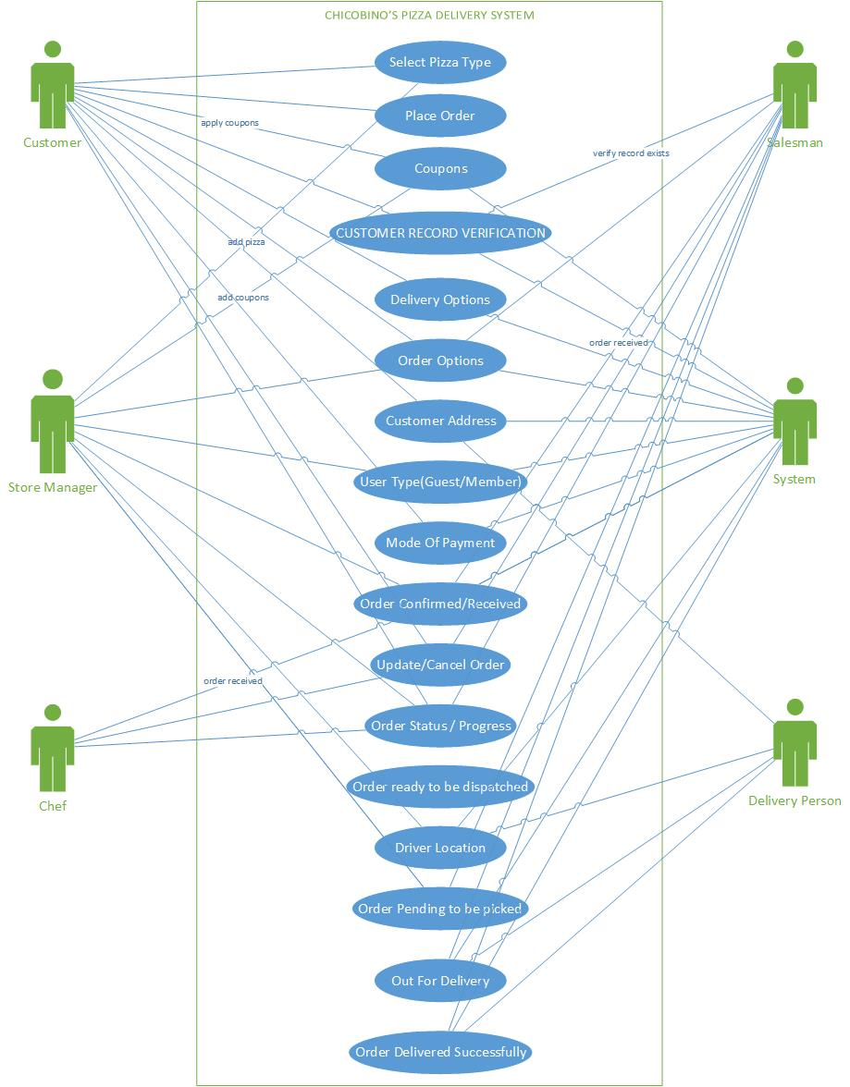

* **Fully dressed format of a Use-Case –**

|  |  |  |
| --- | --- | --- |
| **Use Case:** | Create Order | |
| **Scenario:** | Create an online Pizza Delivery Order | |
| **Triggering Event:** | Customer orders the pizza provides his details to buy a pizza and get it delivered to his/her home. | |
| **Brief Description:** | Customer creates an order to buy pizza and get that delivered at home. After he finalizes everything the order is passed to the salesman and he does further checks and verifies the order before the actual cooking gets started | |
| **Actors:** | * Customer * Salesman | |
| **Related Use Cases:** | Includes: Check Delivery Timings, check for applied coupons, check if within deliverable area. | |
| **Stakeholders:** | * Customer: finalize the order * Salesman: verifies the order | |
| **Preconditions:** | * Customer record must exist in system. * Requested pizza must exist. * Should be open for delivery. * Requested coupon must exists. | |
| **Post conditions:** | * Order must be created. * Order transaction must be created for payment. * A confirmation number must be generated and provided to the user. * Stock for pizza must be updated. * The order must be related to the customer. | |
| **Flow of Events:**  **Flow of Events:** | **Actor** | **System** |
| 1. Customer starts the order and choose from menu 2. Customers can apply valid coupon if exists. 3. Choose the order option, shipping method, payment method and add delivery address 4. Make the payment and finalize order. 5. Can check the status of the order. 6. Receives the pizza. | 2.1 Verify whether the coupon is valid or not.  3.1 Verify the address for cash payment.  3.2. Verify if location is covered or not.  3.3 verify order cancel/update request  4.1 Received the order.  4.2 Chef preparing, checking driver location and after preparation of pizza. Send to delivery driver for delivery.  5.1 Driver delivering to the given address.  6.1 Driver updates the current location, and updates the system with current order status. |
| **Exception**  **Conditions:** | **1.1** If the pizza is not in stock –   1. Notify customer not to choose this one.   **4.1** If customer has a reached credit limit–  a. inform customer to choose different card.  **6.1** If the customer did not give the cash to the driver-   1. Order is cancelled. 2. Order is put on hold until the payment is received. | |

**ACTIVITY DIAGRAM FOR PLACING PIZZA DELIVERY ORDER**

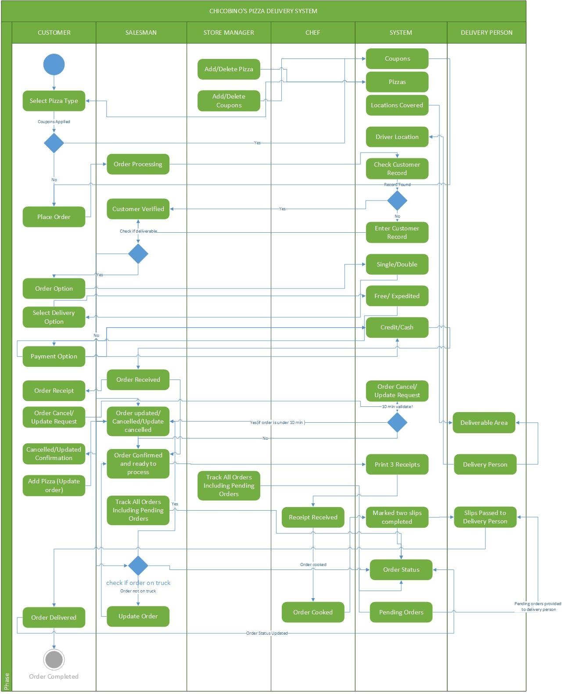

Above is the activity diagram for pizza delivery system. In this diagram, the customer first creates an order which is received by the system and is being verified by the salesman. If the user records exist in the system, he proceeds further otherwise the record is added to the system and proceeded. Then he checks for the valid coupon applied, order options, delivery options and method of payment. If all the checks are passed successfully then after that the order is finalized and confirmed and the receipt for that is provided to the user.

Within 10 mins if the user tries to cancel or update the order, the order is updated and confirmed and acknowledgement for that is provided to the user and order is updated.

Then salesman generates 3 receipts of the order provides to the cook. Cook prepares the order and updates the system with the current status. As soon as the order is ready he marks the order as complete and hands over two slips to the delivery person.

Delivery person keeps his location updated with the system from time to time and then delivery person picks the order and updates the system with current status so that salesman and store manager can keep track of the order. Also he is provided with the list of all the orders pending to be delivered. As soon as the pizza is delivered to the user he updates the system with order successfully completed. If in case user opts for Cash on delivery and unable to provide money. The order is kept on hold and the order is returned back to the branch.